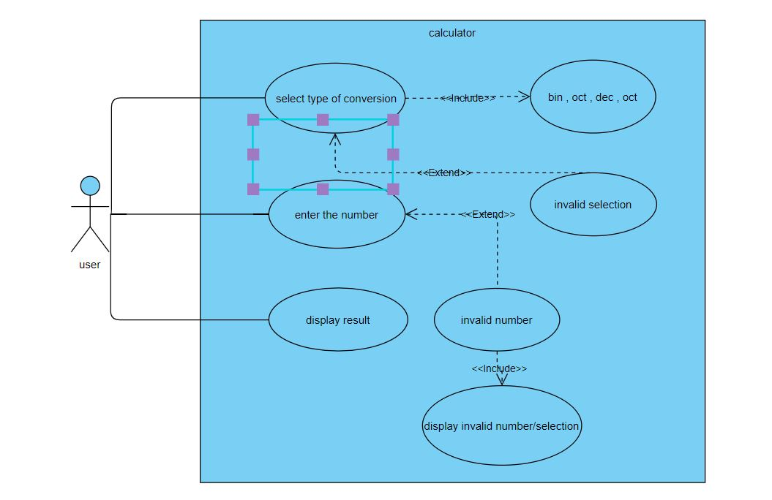
Use case diagram of base conversion

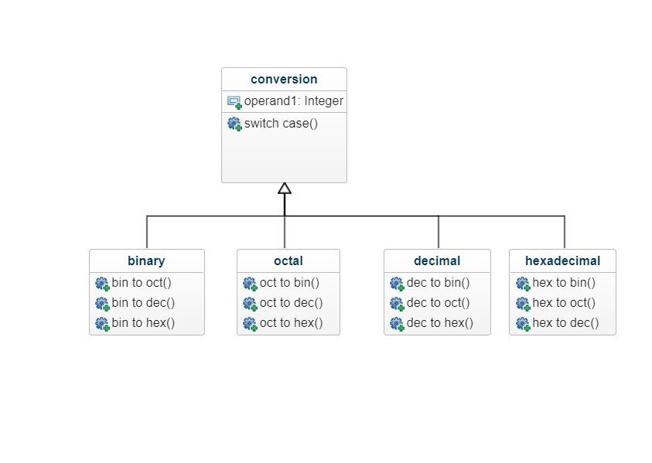
Class diagram

Test plan

id | description | Pre-condition | input | Expected output | Actual output
Test-1 | Work for function bin to dec | Operand must be binary | 1010 | 10
Test-2 | Work for function oct to dec | Operand must be octal | 67 | 55
Test-3 | Work for function dec to hexadecimal | Operand must be decimal | 55 | 37
Test-4 | Work for function dec to hexadecimal | Operand must be hexa decimal | 26 | 38

